A Mini Project Report

On

**“Oil Spill Game”**

submitted in partial fulfillment of the requirements for the award of degree of

**Bachelor of Engineering**

In

**Computer Science and Engineering**

Submitted by

ROHITH INNAMURI 1608-16-733-096

SAI KRISHNA PRASAD 1608-16-733-108

NEELIMA DONKADA 1608-16-733-099

Under the Guidance of

Dr. P. VIJAYAPAL REDDY

Professor & Head of CSE Department

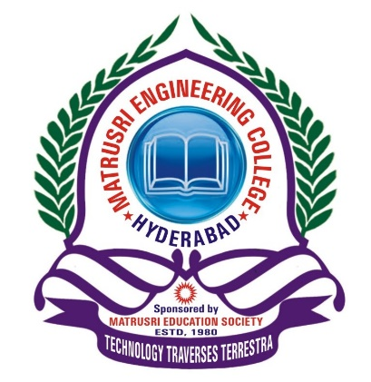

**Department of Computer Science and Engineering**

**Matrusri Engineering College**

(Affiliated to Osmania University, Approved by AICTE)

Saidabad, Hyderabad - 500059

(2017-2018)

**Department of Computer Science and Engineering**

**Matrusri Engineering College**

(Affiliated to Osmania University, Approved by AICTE)

Saidabad, Hyderabad - 500059

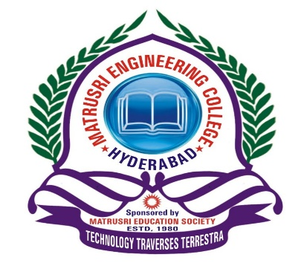

CERTIFICATE

This is to Certify that A Mini Project report entitled **“OIL SPILL GAME**” is being submitted by Rohith Innamuri **(**1608-16-733-096**),** Sai Krishna Prasad **(**1608-16-733-108**),** Neelima Donkada (1608-16-733-099) in partial fulfilment of the requirement of the award for the degree of Bachelor of Engineering in “Computer Science and Engineering” O.U., Hyderabad during the year 2017-2018 is a record of bonafide work carried out by him/her under my guidance. The results presented in this mini project report have been verified and are found to be satisfactory.

**Project Coordinator** **Project Guide** **HOD**

**Mrs. K. Shalini Dr. P. Vijayapal Reddy Dr. P. Vijayapal Reddy**

**Assistant Professor Professor & Head Professor & Head**

**Dept. of CSE Dept. of CSE Dept. of CSE**

**External Examiner(s)**

**CONTENTS**

Acknowledgement 4

Abstract 5

List of Figures vi

List of Tables vii

**S.No Chapter Page No**

1. **INTRODUCTION 7-8**

1.1 Objective 7

1.2 Scope8

1. **ARCHITECTURE & IMPLEMENTATION 9-27**

2.1 Existing System 9

2.2 Proposed System 9

2.3 System Requirements 10

2.4 Code 11

1. **SCREENSHOTS 28-32**
2. **CONCLUSION 33**
3. **FUTURE ENHANCEMENT 34**
4. **REFERENCES 35**

**ACKNOWLEDGEMENT**

It is our privilege and pleasure to express our profound sense of respect, gratitude and indebtedness to our guide Dr. P. Vijayapal Reddy, Professor & Head , Department of Computer Science and Engineering, Matrusri Engineering College, for his/her indefatigable inspiration, guidance, cogent discussion, constructive criticisms and encouragement throughout this dissertation work.

We express our sincere thanks to mini project coordinator **Mrs. K. Shalini**, Assistant professor, Department of Computer Science and Engineering, Matrusri Engineering College, for her valuable suggestions and constant help in completing the work.

We express our sincere gratitude to **Dr. P. Vijayapal Reddy**, Professor & Head, Department of Computer Science and Engineering, Matrusri Engineering College, for his precious suggestions, motivation and co-operation.

We extend our sincere thanks to **Dr. D. Hanumantha Rao**, Principal, Matrusri Engineering College, Saidabad, Hyderabad, for his encouragement and constant help.

We extend our sincere thanks to all the teaching and non-teaching staff of CSE Department for their support and encouragement.

Last but not least, we wish to acknowledge our friends and family members for giving moral strength and helping us to complete this dissertation.